**Single Phase Thyristor Configuration**

Single Phase Thyristor configuration is a commonly used topology for rectifing AC signals.Although this configuration has many advantages,it also has disadvantages either.In order to analyse this topology,a simple circuit analysis is done at Simulink/Matlab.

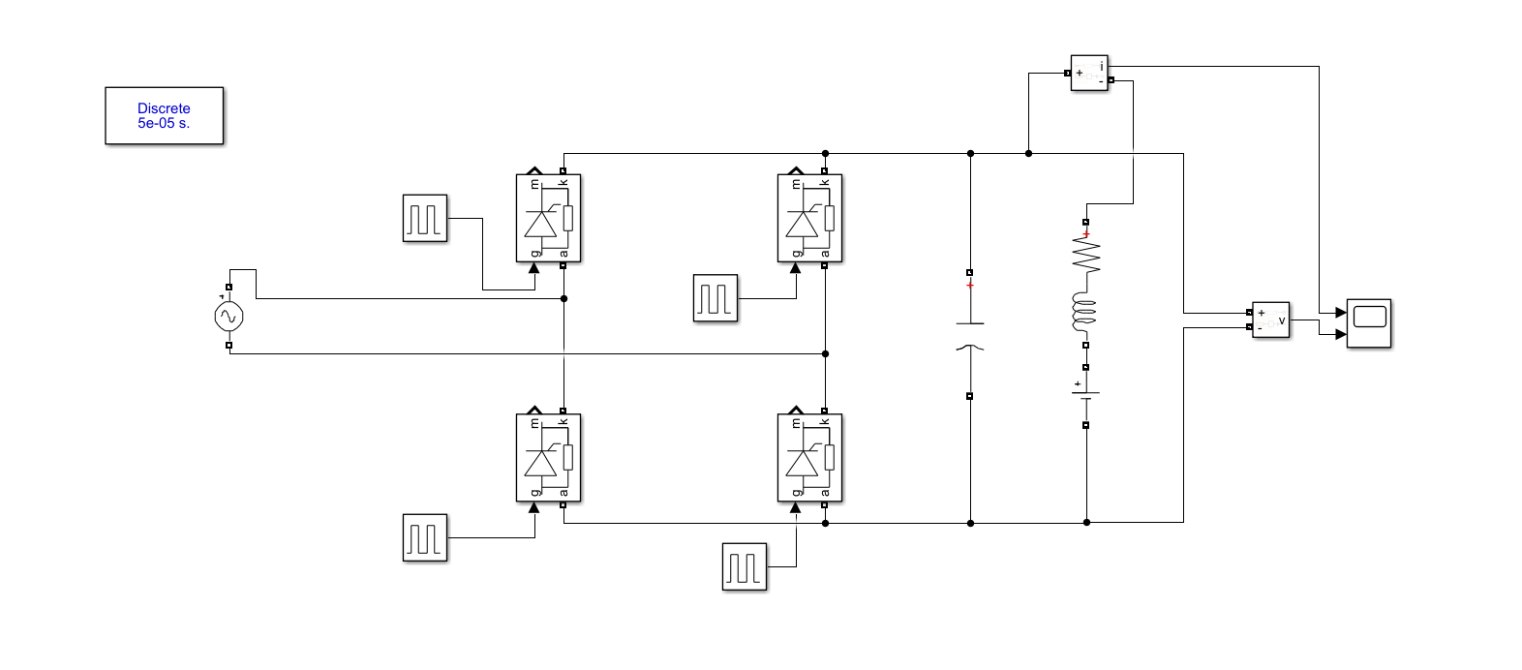

Figure 1:Schematic of Single Phase Controlled Rectifier

DC motor can be represented as a series resistance R(0.8Ω) ,series inductance L(12.5mH) which are the armature resistance and inductance values and DC voltage source to represent back EMF(considered as 100V) as in the figure above.

One of the main problems of this topology is that the capacitor that is used for making the ripple of the output voltage($V_{p-p}$) smaller ,needs to be too large.For example,according to simulations,i.e. figure 2,the neccesary capacitor to make output ripple as small as in the figure 2 is 100mF which is a very large capacitor.Anoher problem is that,although the pulse generators seem simple at figure 1,they are not in real life.Additional pulse generator circuits needs to add to system in order to maket his topology operate properly.Also,synchronizing these pulse generators according to proper firing angles(α) is a serious problem.

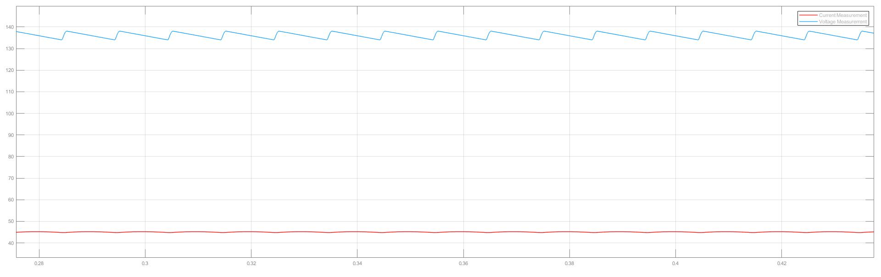

Figure 2:Voltage and Current Waveforms of Single Phase Thristor Rectifier

As all engineering applications,this topology has advantages and disadvantages.

-The Advantages of this topology;

1. It’s four quadrant operation is much simpler than diode rectifier-buck converter configuration.
2. Cheaper
3. Easier to achieve simplicity bonus

-The Disadvantages of this topology;

1. Aranging and synchronizing the firing angle of the gate signal
2. Gate driving circuit is hard to implement
3. The capacitor at the load side needs to be larger compared to Diode Rectifier+Buck Converter Topology

However,as M.P.W.U. ,we decided not to use this topology because when we consider Diode Rectifier+Buck Rectifier topology and this topology ,the disadvantages for this topology preponderated.